PURPOSE
To ensure that the recording of time during paper, phone and field tracking by data collectors or trackers is done in uniform and standard manner thereby minimizing the risk of errors. This SOP covers all the 3 key stages of tracking.

SCOPE
This SOP procedures apply to all staff that are involved in paper, phone and field tracking of LTFU patients.

RESPONSIBILITIES
- All staff involved in tracking of LTFU patients of trackers will comply with the requirements of this SOP.
- The Monitoring and Evaluation Officer is responsible to ensure that all staff are trained and that training is documented.
- Tracker: It the responsibly of the Tracker to correctly record time correctly.
- Assistant Study Coordinator (ASC): It is also the responsibility of the ASC to provide guidance on any queries that may arise from the trackers on how to best record time.

PROCEDURES

Time Spent Paper Tracking

The approximate time spent looking for a patient’s file should be indicated in A17 under Module A.
A17. Approximately how much time was spent looking for this patient’s file and recording the necessary information? | :
 | Hours (hh) : Minutes (mm)

This means that the Tracker should be able to time himself/herself using a watch/timer when paper tracking begins. The Tracker should record the actual time spent looking for the file and recording all the necessary information. The time spent on other things apart from paper tracking should not be included. For instance, the time taken to pay courtesy call to the facility in-charge and health care workers should not be included. As indicated, if the tracker spent only1 hour 30 minutes, this should be clearly recorded as shown below.

 | 1 | : | 3 | 0
Hours (hh) |  |  | Minutes (mm)

Similarly, if the tracker only spent only 1 hour, this should be clearly recorded as shown below:

 | 1 | : | 0 | 0
Hours (hh) |  |  | Minutes (mm)

Similarly, if the tracker only spent only 30 minutes, this should be clearly recorded as shown below:

 | 0 | : | 3 | 0
Hours (hh) |  |  | Minutes (mm)

Time Spent by Phone looking for a Patient

The Tracker should ensure that the actual time spent to trace a patient on phone is clearly recorded in the daily tracking log. This should be recorded under the fourth (4th) column which read ‘Time spent by phone’ as shown in the figure below:

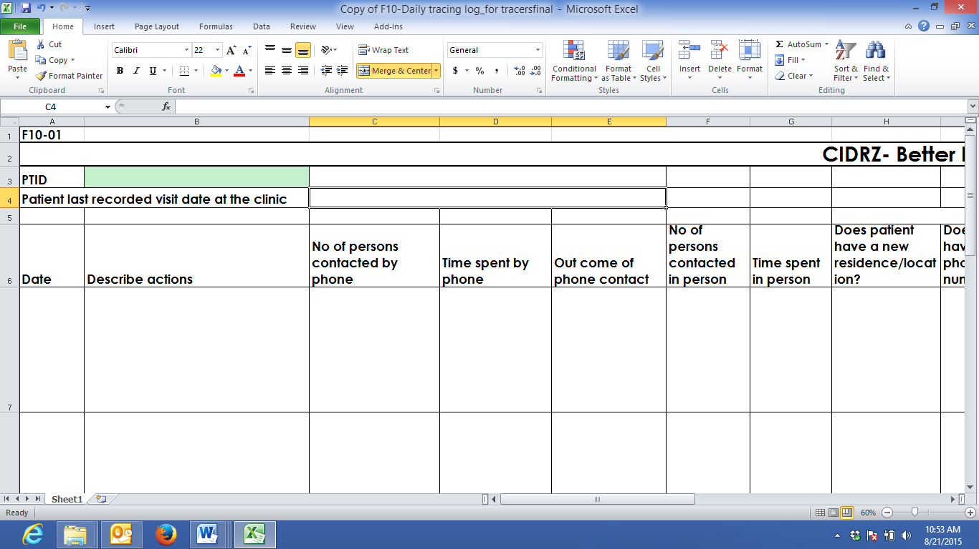

Therefore, the Tracker should add ‘all the recorded time spent to track a patient by phone’ from the Daily Tracking Log and the total time spent (hours and minutes) should be recorded in the computer tablet using the format provided below in B.4.4:

B.4.4. How many hours were spent by phone looking for this patient? | :
 | Hours (hh) : Minutes (mm)

Scenario 1: A Tracker makes the 1st phone call to a key informant for Patient XXX and this lasts for about 30 minutes. This should be recorded in the Daily Tracking Log. Based on the phone call with key informant, the Tracker gathers new information and finally makes the 2nd phone call to Patient XXX. This 2ndphone call lasts for 1 hour 20 minutes. This time spent by phone is also recorded in the Daily Tracking Log. Therefore, to get the ‘actual time spent by phone looking for this patient’, the Tracker should add all the times spent on phone calls for Patient XXX ONLY. In this case, it will be 1st Phone call (30 minutes) + 2nd phone call (1 hour 20 minutes) = 1 hour 50 minutes. Therefore the time spent by phone looking for this patient which will be entered in the computer tablet is 1 hour 50 minutes.

Time Spent in Person looking for a Patient

The Tracker should ensure that the actual time spent to track a patient in the field is clearly recorded in the daily tracking log. This should be recorded under the seventh (7th) column which read ‘Time spent in person’ as shown in the figure below:

The actual time spent looking for a patient should also include the travel time for the tracker to move from the health facility to the patients’ place and back.Therefore, the Tracker should add ‘all the recorded time spent to track a patient in-person’ from the Daily Tracking Log and the total time spent (hours and minutes) should be recorded in the computer tablet using the format provided below in B.4.5:

B.4.5. How many hours were spent in person looking for this patient? | :
 | Hours (hh) : Minutes (mm)

Scenario 1: A Tracker has only 1 appointment with Patient ZZZ on a particular day. Patient ZZZ lives in a community 50 Km away from the health facility. It takes the Tracker 1 hour 30 minutes of travel using a Bicycle. The Tracker spends 2 hour 15 minutes with consenting and interviewing Patient ZZZ. This information is recorded in the Daily Tracking Log. Therefore, the actual time spent tracking the patient will be travel time (round trip / go-come) plus total time spent with the patient, which is equalto5 hour 15 min i.e. (1 hour 30 mins plus 2 hrs 15 mins plus 1 hour 30 minutes) for going back. This can be illustrated using the formula below:

Actual Time  spent in-person looking for Patient ZZZ | = | Travel Time + Total Time Spent with Patient

Actual Time  spent in-person looking for Patient ZZZ | = | 1 hr 30 min + 1 hr 30 min (Travel Time) + 2 hrs 15 min (Total Time Spent with Patient)

Actual Time  spent in-person looking for Patient ZZZ | = | 5 hrs 15 minutes

Scenario 2: A Tracker has 2 appointments with Patient XXX and Patient YYY on the same day. Patient XXX and Patient YYY are within the same neighbourhood. From the health facility to the house of Patient XXX, it takes the Tracker 1 hour 15 minutes of travel using a Motor bike. The Tracker spends 1 hour 26 minutes with consenting and interviewing Patient XXX. This information is recorded in the Daily Tracking Log. The Tracker then takes a lunch break of 1 hour before travelling for 45 minutes to the other Patient YYY within the same neighbourhood. The Tracker spends 1 hour 50 minutes with the consenting and interviewing Patient YYY. The tracker then spends 30 minutes travelling back to the health facility at the end of the day.This information is also recorded in the Daily Tracking Log. The actual time spent tracking each patient will be counted for that individual patient and the travel time will be added up anddivided by number of patients tracked. This can be illustrated using the formula below:

Travel Time looking for a Patients XXX and YYY  Actual time spent in person looking for Patient XXX  Actual time spent in person looking for Patient YYY | = | Travel Time (1 hour 15 min +45 min + 30 min)
 | = | Number (#) of Patients Traced (2)  = 75 min+45min++30min = 150min/2 pts  = 75 min per patient  = 1 hr 15 min per patient  = Travel time calculated above (1 hour 15 min) + 1 hour 26 minutes = 2 hrs 41 min  = Travel time calculated above (1 hour50 min) + 1 hour 15 minutes = 3 hours 05 min

If any additional trips are made to get further information about these same patients, that travel time and in-person time should also be added to the total for the appropriate patient. It is possible that more than 1 in-person trip may be made per patient.

Note (added on 21st March 2016):

Based on some clarifications from Eastern and Western Province on calculation of time spent during field tracking in situations where the tracker has to track a patient who is in another place (district/province) and has to spend a night in that place.

In order to determine the time spent in-person looking for a patient, the tracker should include the travel time from the health facility to patients place plus (+) actual consenting and interviewing time plus (+) travel back time. But, the time spent sleeping overnight should not be included in the time calculation.

In addition, we do want the trackers/tracker supervisors to include the full 'working hours' of the days spent looking. For example, if a tracker makes an attempt and is told to come back tomorrow and is thus prevented from doing other work because s/he is out of town, the remaining work hours for that day should be counted.

In situations where the tracker was tracking more than 1 patient, then the time calculation will be as follows: average travel time (total travel time divided by number of patients followed up/tracked on that round trip) plus consenting and interviewing time.

